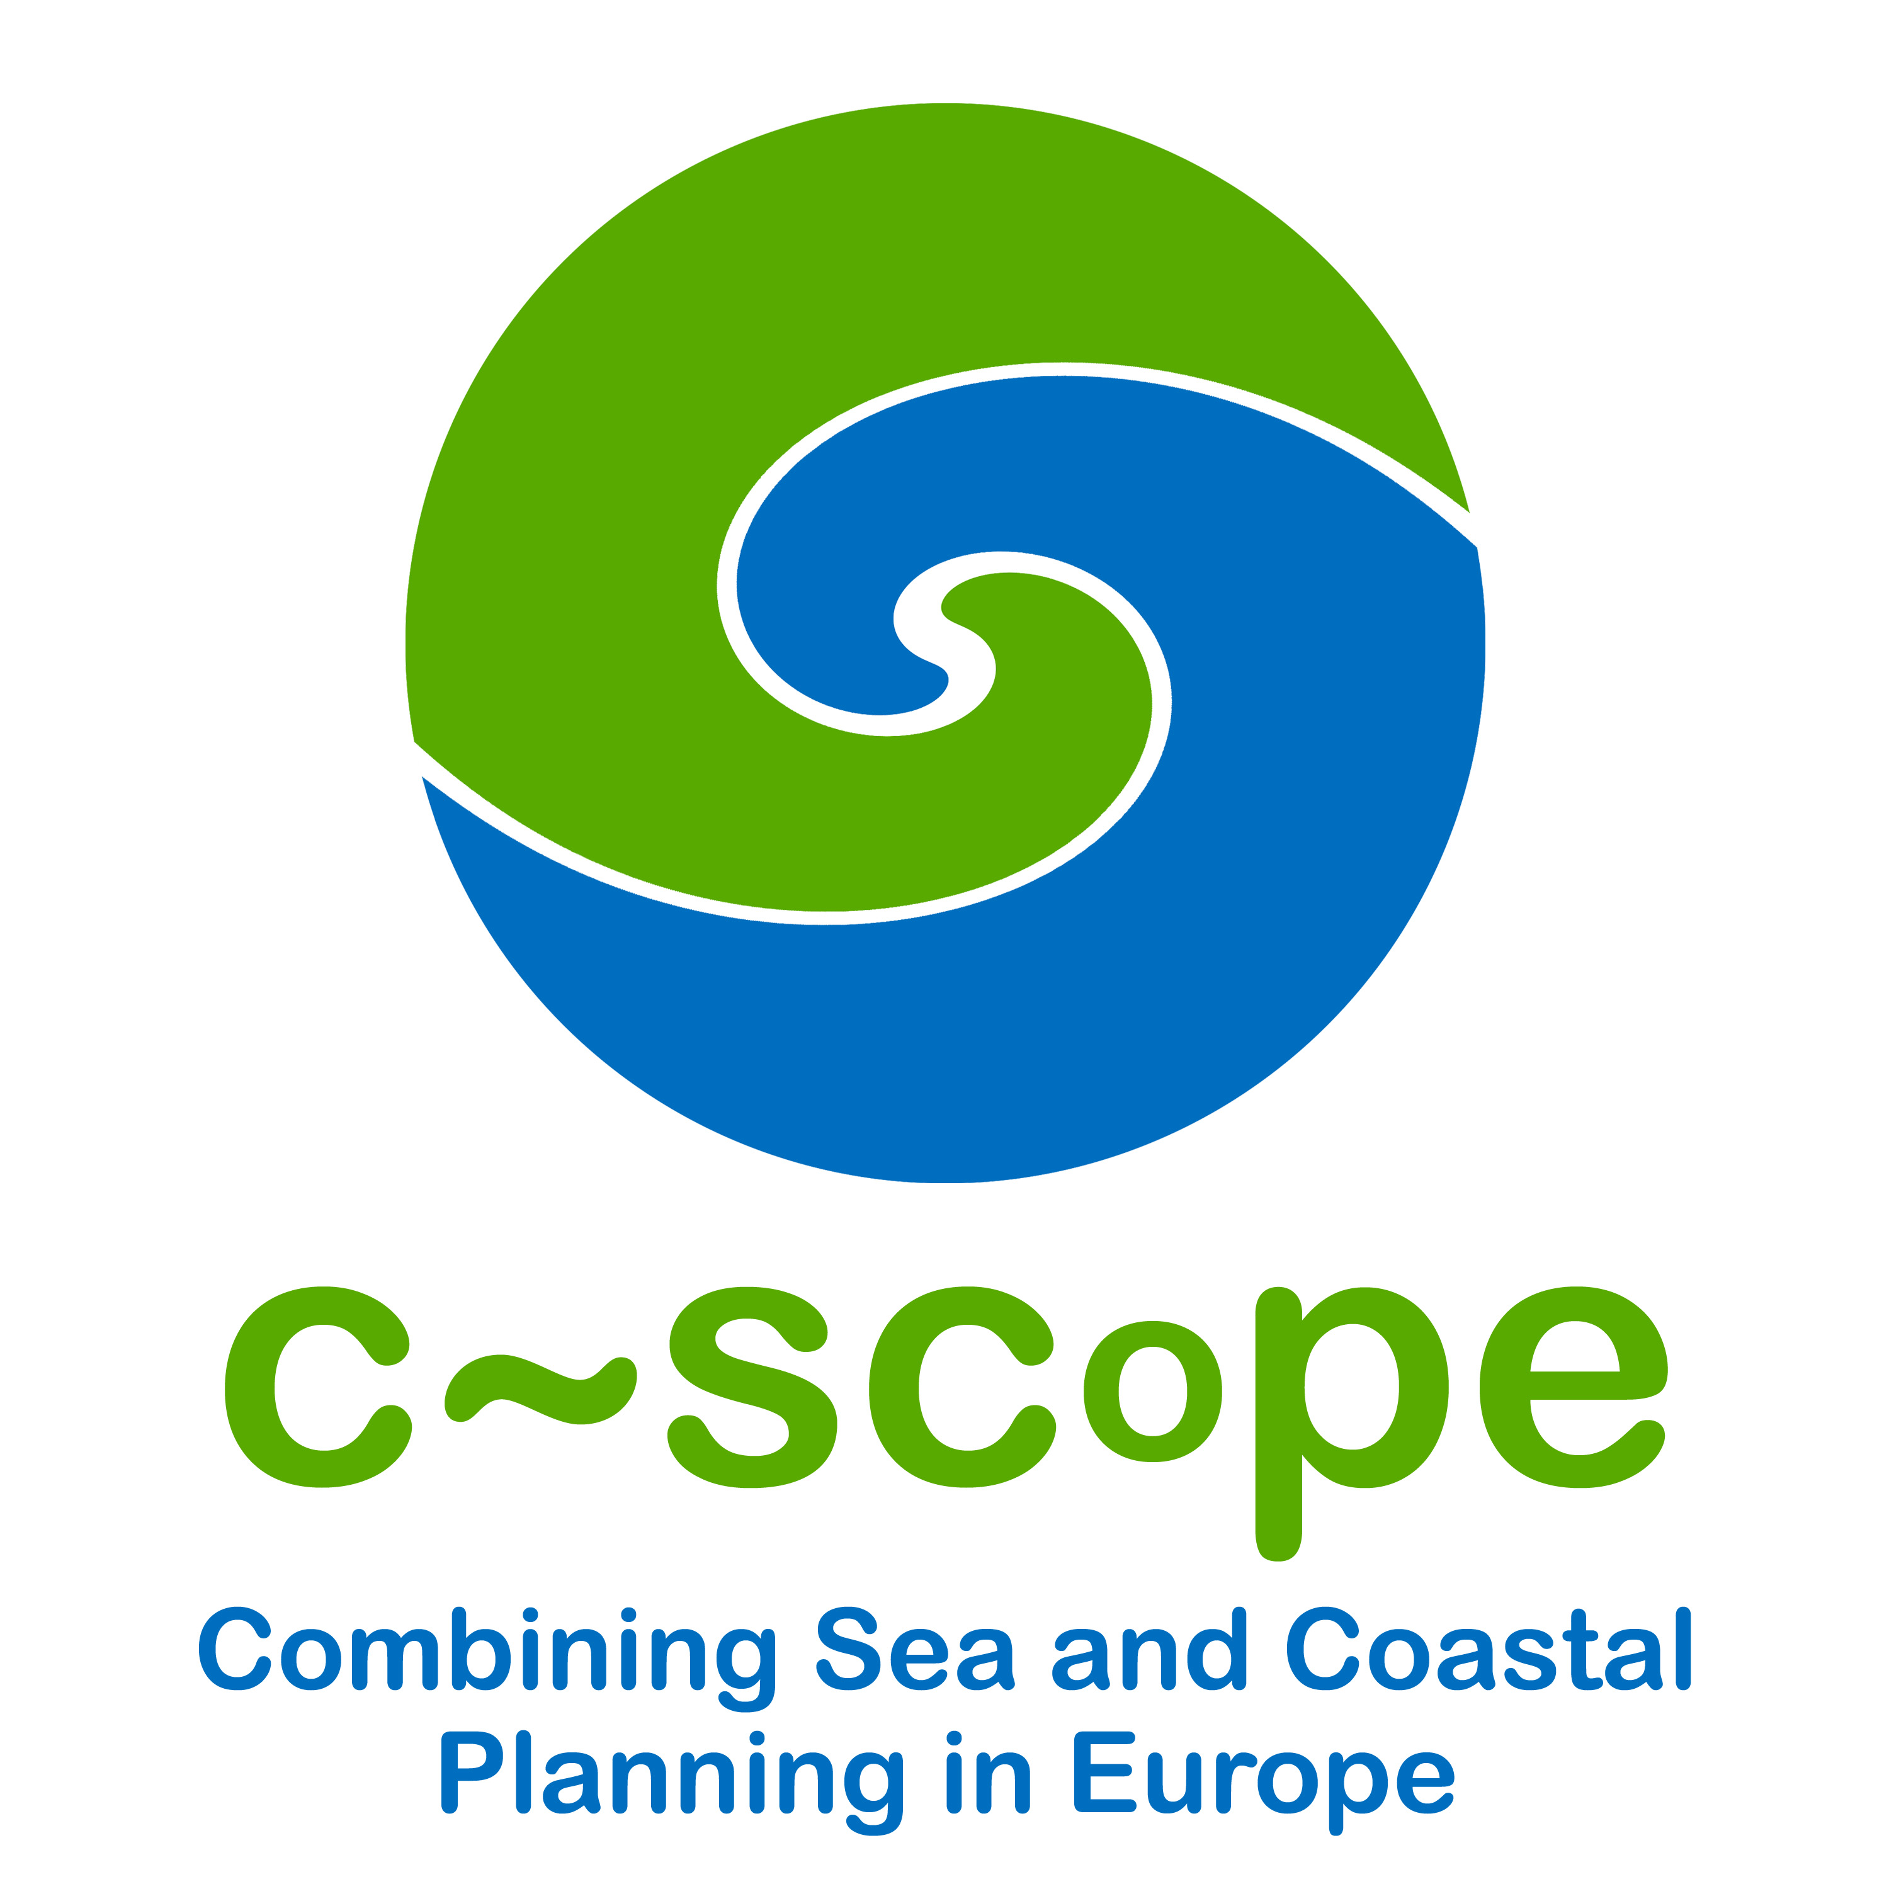

Draft Agenda for the C-SCOPE PCM Visit Day

18th August 2009

9:30 am Portland Marina

10.45 am Weymouth and Portland Sailing Academy

11:45 am Portland Port

12.30 pm Lunch - Venue TBC

2:00 pm Coastal processes and defence walkabout

4:00 pm Finish

